Cloud Electronic Folio

Manoj Babu G R, Samuel T, Anusha S, Purushoham S and Prof. Manimegalai Department of Computer Science and Engineering, East Point College of Engineering and Technology, Bangalore, Karnataka, India (Affiliated to Visvesvaraya Technological University, Belagavi).

[1ep18cs054.epcet@eastpoint.ac.in,](mailto:1ep18cs003.epcet@eastpoint.ac.in) 1ep18cs079.epcet@eastpoint.ac.in,1ep18cs010.epcet@eastpoint.ac.in,1ep18cs091.epcet@eastpoint.ac.in, manimegalai[@eastpoint.ac.in](mailto:dremilin@eastpoint.ac.in)

***Abstract* -“**Cloud Electronic Folio” is a cloud-based online self-portrayal application designed to showcase oneself with context to the professional life or career perspective. LinkedIn, Instagram, Pinterest, Facebook pages, etc., are great. But do you know what’s even better? A personal website to tell the world who you are and what you do best. A digital portfolio gets your name out there, generates credibility, and – if designed well – it gives you that WOW factor making you stand out from the competition.

A web-based portal where users can update their information to showcase all that they can do as in a simple Resume or CV in a more visual and interactive way. Through this portal, a user can update his/her Portfolio online and make it available with just a link. A person can define all the details of his professional career through a link. It's feasible to carry around or remember just a link rather than having to carry over two sheets of paper as a resume or a document on phone. Employers from different companies can review these Portfolio profiles to look if the profile matches their Job Description for their Job defined. Users and Employers can use this portal without any geographical barrier, from any part of the world. This application is also developed by using some cutting-edge technologies that are in great demand in the IT industry today. Some of them are Serverless (AWS Lamba, Azure Functions), Node.js, Python NLP, React.js, Cloud Technology, No-SQL structured Databases, etc.**,**

**INTRODUCTION**

Cloud Electronic Folio is a SaaS based application where anyone can create an online portfolio for themselves for free and use it for their reference. The intention is to eliminate barrier to showcase their personal and professional work in a more defined and interactive manner. Users also get to carry a link which is very simple rather than to carry forward resumes for every interview they go to.

An online portfolio would leave a chance for a user to showcase their creativity in terms of display of their work and accomplishments. Here is also possibility to connect and grow network among profiles keeping Alumni network as main stream goal.

**THEORETICAL FRAMEWORK**

Our objective is to simplify the process of creating an resume without hustle. Cefoio provides an user friendly interface to create an resume without requirement of complex coding or prior knowledge. Cefolio handles various formats and fields from user and provide standard templates which user can use to create resume.

95% of the candidates get rejected during the initial rresume shortlisting round due to inappropriate format, wording, spelling mistakes, etc… We try to solve this core problem.

Core team of Cefolio has researched and analysed various resumes to understand the key points that the Employer expects in an candidate. The analyses has helped the team to develop Cefolio product that candidate utilize and have higher probability of getting shortlisted in organisation.

We have developed an core effective algorithm to handle various format and fields of user input, handle users with varying knowledge to provide best experience while using application.

We have immediate view feature, which users can utilize to see the immediate changes that user does without downloading the resume. This is accomplished by maintaining the store of user data real time.

Cefolio developers follow CI/CD process to push code and reflect new features that users can immediately utilize in Production time with no downtime in deploying the changes/features.

As a final step, we continuously monitor and analyze user actions in the Cefolio Product to improve and provide best outcomes to the end user

**OBJECTIVES**

The objectives of this project are:

* Create a Portfolio free of cost and host without any charges to the user.
* Maintain code structure to well design the templates of the Portfolios. To perform grammatical checks on the data being uploaded and correct them for exactness.
* To start a referral eco-system of jobs.
* A two-minute introductory Video Resume on-demand.
* Connect Alumni Network.

**LITERATURE REVIEW**

The proliferation of the internet has made it an increasingly popular tool for millions of job seekers searching for work. At the forefront of this surge are job portals connecting prospective employees with potential employers. In India, there are over 10 job portals operating nation-wide – though when we launched our experiment, Job-Shikari was one of the only ones advertising blue collar employment opportunities. This has been quoted from the paper: “How do Online Job Portals affect Employment and Job Search? Evidence from India” by Erin M. Kelley, Christopher Ksoll and Jeremy Magruder (December 17, 2020).

In the present scenario of increasing penetration of internet usage, preference of smart phones by different cross sections of the society and developments in information technology. Online recruitment (erecruitment) portals like, naukri.com, timesjobs.com, monsterindia.com, indeed-one search all jobs, jobsahead.com, careerbuilder.com, shine.com, freejobalerts.com, facultyplus.com jobsahead.com etc. in the developing country like India awareness and adoption (usage) is bound to play a significant value exchange between job seekers as well as job givers. This has been quoted from the paper: “A Study on Online Recruitment (E-Recruitment) Portals Adoption (Usage): Role of Demographics in Kolkata City” by Thirupathi Chellapalli and D.V. Srinivas Kumar (2018)

**METHODOLOGY**

In order to host websites in a robust manner, we will be using Azure technologies to host the application. We would be handling the functions of the websites in a Lambda Architecture where the application as a whole does not act, but the application in pieces does and integrate over the APIs. We have chosen React.js as our front end so we have efficient responsive websites or user interface. Canva as a UI/UX designing tool, where we will be initially designing all the icons and templates that are required for building our websites. To the backend we are using Node.js to support the application and Python Flask to run the serverless application functions. This would enable us to easily integrate the applications and run it as a whole.

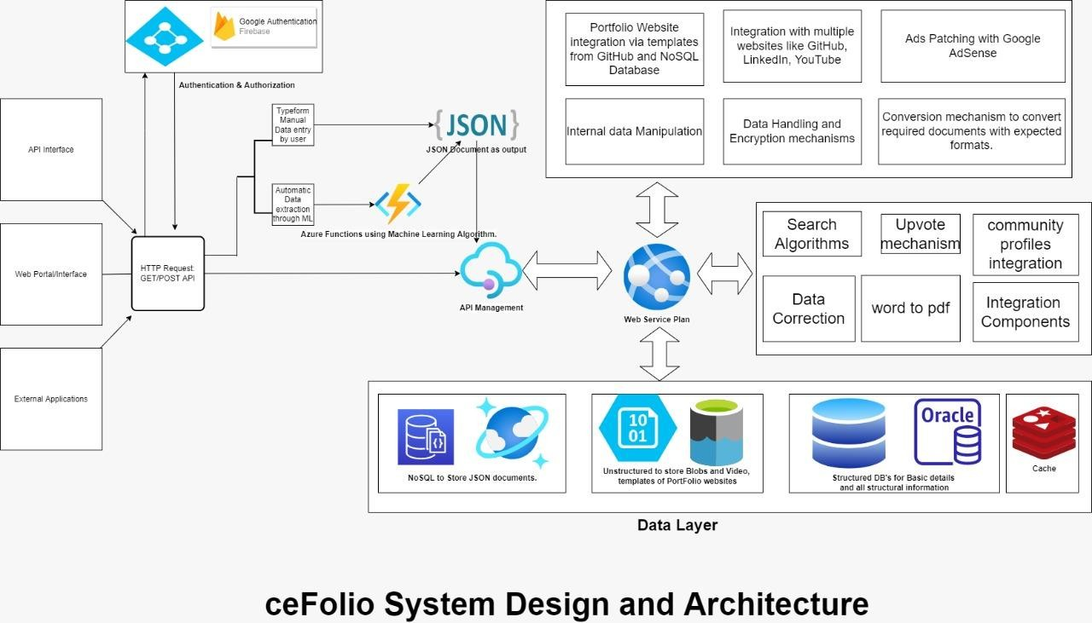

**Fig 5.1:** Overview of the Theoretical Framework of the Proposed System

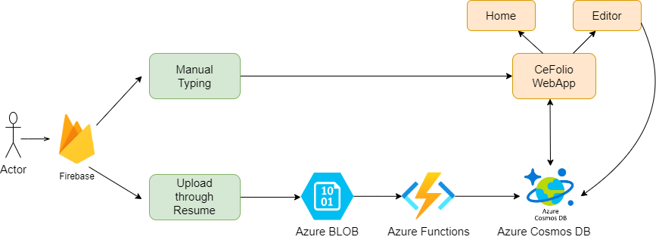

**Fig 5.2**:data flow diagram

**OUTPUT**

In this you can see that front page of the web application.

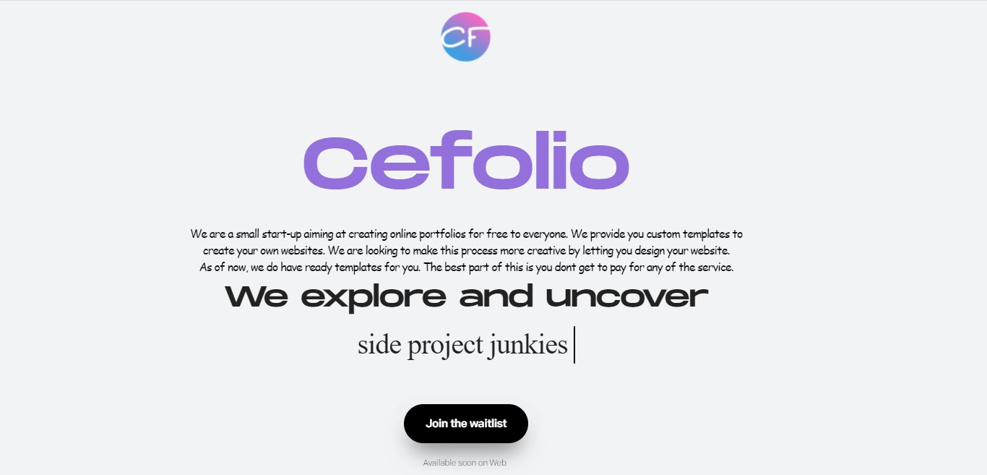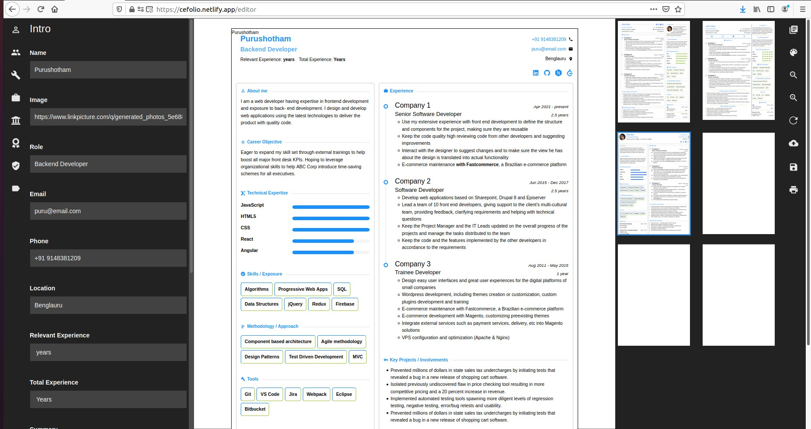

The figure above illustrates how different types templates can be selected and data can be inserted, and how it gives a web view for a resume and portfolio’s

**CONCLUSION**

Online Portfolio is one of the emerging ways to showcase someone's skills in more effective and interactive manner. Here a User will be provided a link which is very simple to remember and carry around. A user does not have to carry around a resume anymore, the ecosystem of viewing the resume in textual formats could be eliminated and a more graphical/visual representation of oneself can be presented to the interviewer.

Many more features are to be added, this is just a beginning to future of showcasing persona in a professional or career-oriented manner. We aim to eliminate the legacy process of shortlisting users based on resume where the actual potential is not considered. Hence going forward, we would be implementing algorithms to rank these portfolios based on specific criteria on which these can also be consumed by Hiring managers.

**REFERENCES**

[1] Online recruitments Portals 2018. <http://journal.iujharkhand.edu.in/A-Study-On-Online-Recruitment.pdf>

[2] Job Portals affecting employment in India 2020. [https://www.povertyactionlab.org/sites/default/files/research-paper/working-paper-](https://www.povertyactionlab.org/sites/default/files/research-paper/working-paper-3740_online-job-portals_india_magruder_dec2020.pdf) [3740_online-job-portals_india_magruder_dec2020.pdf](https://www.povertyactionlab.org/sites/default/files/research-paper/working-paper-3740_online-job-portals_india_magruder_dec2020.pdf)

[3] IEE - Job Portal - A Web Application for Geographically Distributed Multiple Clients 2014 <https://ieeexplore.ieee.org/document/6959916>